Create a tables name SALES_REP. The table has the same structure as the REP table shown in Figure 3-11 except the LAST_NAME column should be use the VARCHAR data type and the COMMISSION and RATE columns should use the NUMBER data type. Execute the command to describe the layout and characteristics of the SALES_REP table.

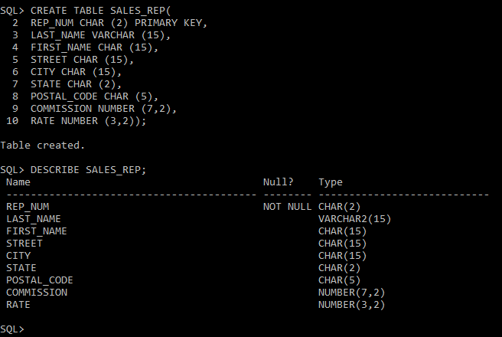

Add the following row to the SALES_REP table: rep number: 35, last name: Lim; first name: Louis, street: 535 Vincent Dr.; city: Grove; state: CA, postal code: 90092; commission: 0.00; and rate: 0.05. Display the contents of the SALES_REP table.

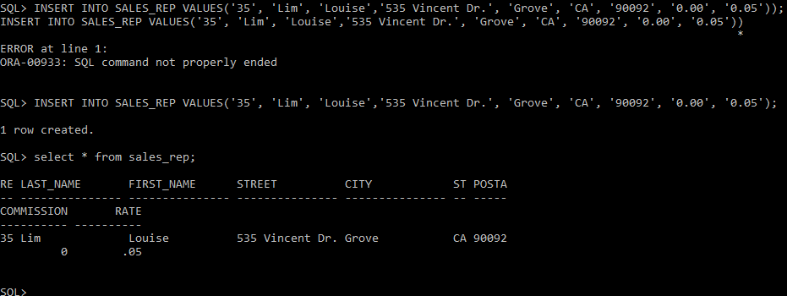

Delete the SALES_REP table.

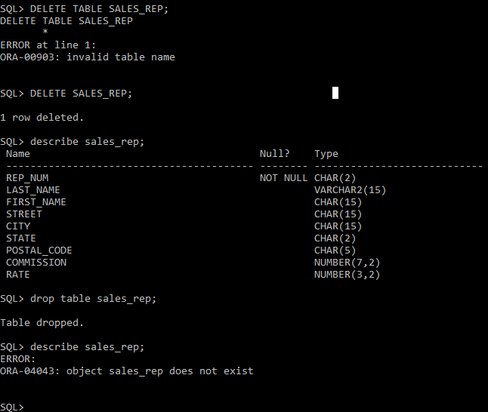

Run the script for the TAL Distributors to create the five tables and add records to the tables. Be sure to select the file for the particular DBMS that you are using (Oracle, SQL Server, or Access). (Note: if you do not have the script files for this text, ask your instructor for assistance.)

Confirm that you have created the tables correctly by describing each table and comparing the results to Figures 3-11, 3-30, 3-32, 3-34, and 3-36.

Confirm that you have added all data correctly by viewing each table and comparing the results to Figure 2-1 in Chapter 2.

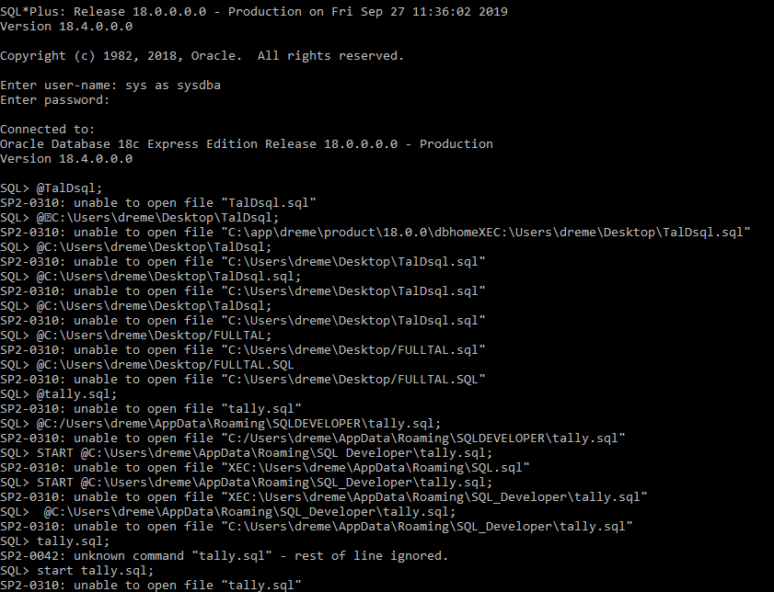

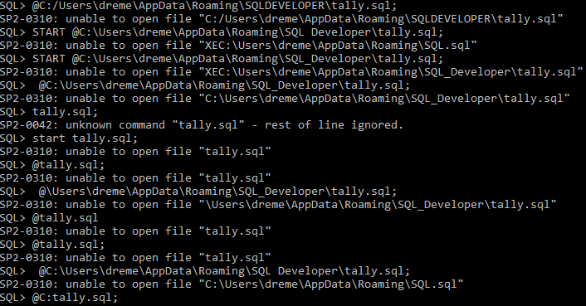

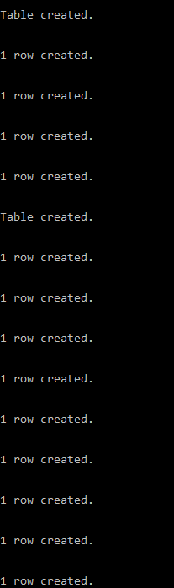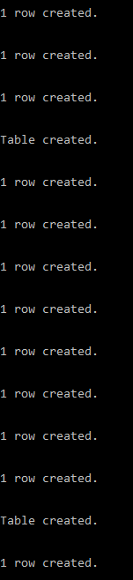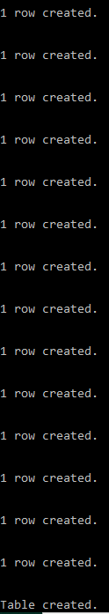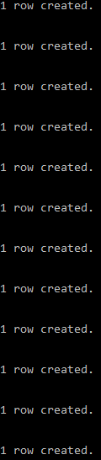

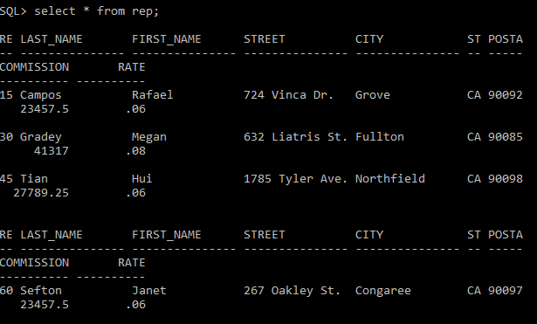

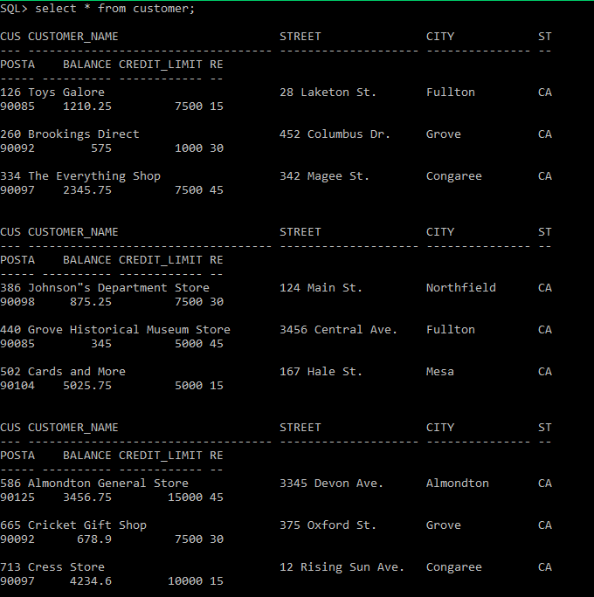

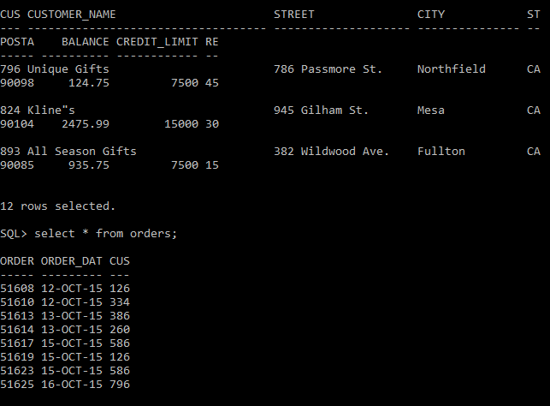

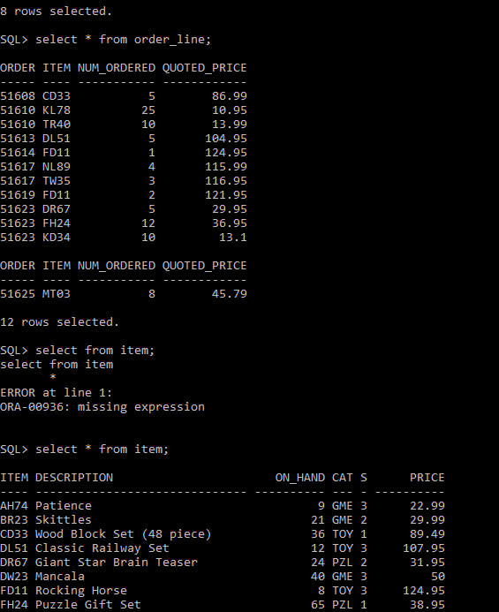

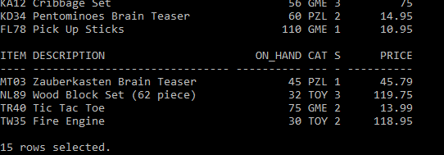

Review the data for the ITEM table in Figure 2-1 in Chapter 2 and then review the data types for the DESCRIPTION, ON_HAND, and STOREHOUSE fields and explain your recommendations

The data type for the Description column can be either VARCHAR or CHAR. The on-hand data type for the ON_HAND column could be CURRENCY OR NUMBER and the STOREHOUSE data type could be INT, TINYINT OR SMALLINT.